Project Design Phase
Solution Architecture

Date | 10 FEB 2026
Team ID | LTVIP2026TMIDS24974
Project Name | Toycraft Tales: Tableau's Vision into Toy Manufacturer Data
Maximum Marks | 4 Marks

Solution Architecture:
Solution architecture is a multifaceted process made up of several interconnected activities that connect business challenges with appropriate technological solutions. Its main objectives include:

● Identifying the most suitable technology approach to address current business issues.
● Explaining the system’s structure, functionality, behavior, and key attributes to stakeholders involved in the project.
● Outlining required features, development stages, and overall solution expectations.
● Establishing clear specifications that guide how the solution is designed, implemented, and maintained.

Example - Solution Architecture Diagram:

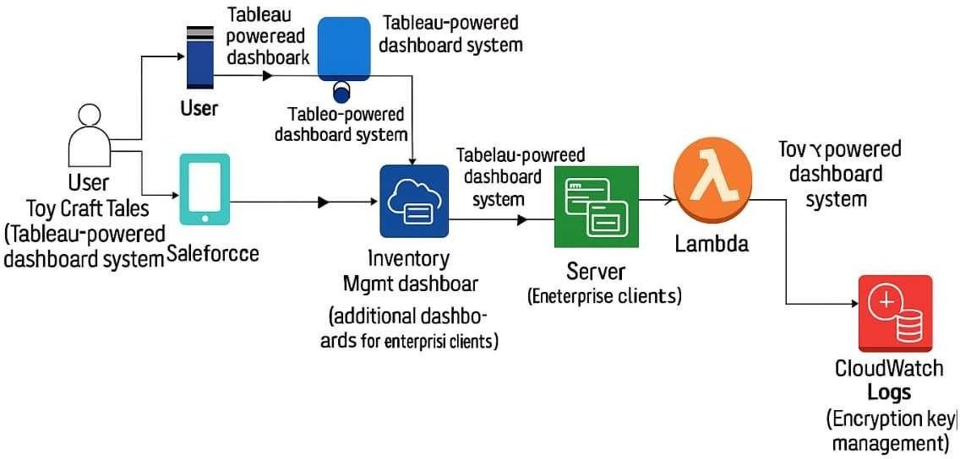

Figure 1: Architecture and data flow of the voice patient diary sample application
Reference: https://aws.amazon.com/blogs/industries/voice-applications-in-clinical-research- powered-by-ai-on-aws-part-1-architecture-and-design-considerations/

